Answer all questions in the spaces provided
1 | The elements in the Periodic Table form the building blocks of all substances and can be broadly classified as metals and non-metals.
 | (a) | Potassium and copper are metals from Period 4 of the Periodic Table.  Potassium is a soft, silvery white metal that tarnishes readily in air. Copper is a hard, reddish metal that is resistant to corrosion at ordinary temperature.  Metallic potassium has no commercial uses, but copper is used widely to make electrical wires.  Data about potassium and copper are given as follows:
   | atomic radius / nm | density / g cm⁻³
  potassium | 0.221 | 0.826
  copper | 0.117 | 8.95
 |  | (i) | Given the electronic configuration of potassium below, write down the full electronic configuration of copper below.
 |  |  | potassium: 1s² 2s² 2p⁶ 3s² 3p⁶ 4s¹
 |  |  | copper:
 |  | (ii) | Although copper has more electrons than potassium, the atomic radius of copper is smaller than that of potassium.  Account for the difference in atomic radii of the two elements.
 |  | (iii) | By considering the arrangement of particles in a metallic lattice, suggest an explanation for the difference in the densities of the two metals.
 |  |  |  |  | [5]
 | (b) | The hydrides of group VII elements are dissociated at high temperatures according to the equation:  2HX(g) → H₂(g) + X₂(g)
 |  | (i) | With reference to relevant data from the Data Booklet, describe and explain the trend observed in the relative stabilities of the hydrides of chlorine, bromine, and iodine.
 |  | (ii) | State the intermolecular force responsible for the higher boiling point for the hydride of fluorine, compared to the hydrides of chlorine, bromine, and iodine, despite having a much lower relative molecular mass.
 |  |  | [4]
 | (c) | Helium and neon are non-metals from Group 0 of the Periodic Table. These elements exist as monoatomic gases and are commonly used in advertising tubes.  When a minimum potential difference of 24.0 V is supplied to an advertising tube containing helium, the gaseous atoms gain sufficient energy to become ionised.  Use relevant data from the Data Booklet to estimate the minimum potential difference required to ionise neon in an identical advertising tube.
 |  | [2]
 |  |  | [Total: 11]
2 | Calcium oxalate, CaC₂O₄, is a white needle-like crystalline solid. On strong heating, calcium oxalate decomposes to produce carbon monoxide.
 | (a) | (i) | Draw a ‘dot-and-cross’ diagram to illustrate the bonding of the anion in CaC₂O₄.
 |  | (ii) | Hence, draw the shape of the anion in CaC₂O₄, showing the values of the bond angles.
 |  |  | [3]
 | (b) | When 0.128 g of anhydrous CaC₂O₄ was heated at 400 °C until no further change in mass is observed, a white solid B and 0.028 g of carbon monoxide gas is obtained. No other substances were formed.
 |  | (i) | Suggest and explain one precaution that should be taken when heating calcium oxalate in the laboratory.
 |  | (ii) | Given that 1 mole of CaC₂O₄ decomposes to form 1 mole of B, use the information given to determine the M_{r} of B.
 |  | (iii) | Based on your answer in (ii), suggest the identity B.
 |  | (iv) | Hence, write a balanced equation for the thermal decomposition of calcium oxalate.
 |  | (v) | Predict a value for the thermal decomposition temperature for barium oxalate, given that it is 400 °C for calcium oxalate. Explain your reasoning.
 |  |  | [9]
 |  |  | [Total: 12]

3 | Propanone is a useful organic solvent due to its ability to dissolve a variety of compounds.
 | (a) | Propanone can be synthesised in the laboratory from 1−chloropropane by a method which involves one intermediate product A.
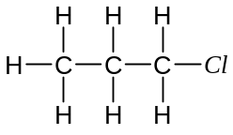
KOH, CH₃CH₂OH
reflux

A

Step II

B

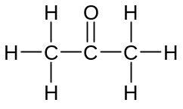
Step III

 |  | (i) | Write the formula of A and B in the space above.
 |  | (ii) | Suggest reagents and conditions for
 |  |  | Step II:
 |  |  | Step III:
 |  |  | [4]
 | (b) | Propanone undergoes nucleophilic addition with hydrogen cyanide in the presence of a trace of sodium hydroxide to form a cyanohydrin.
 |  | (i) | Write an equation to show how the nucleophile is generated.
 |  | (ii) | Outline the mechanism of the reaction, using curly arrows to show the movement of electrons during the reaction.
 |  | (iii) | The cyanohydrin formed can be converted into 2-hydroxy-2methylpropanoic acid. Suggest reagent and conditions for this reaction.
 |  |  | [4]
 | (c) | 2-hydroxy-2-methylpropanoic acid (can be represented as HA), is a monoprotic weak acid with an acid dissociation constant, K_{a}, of 2.05 x 10⁻⁵ mol dm⁻³.  In an experiment, 20.0 cm³ of 0.100 mol dm⁻³ 2-hydroxy-2-methylpropanoic acid was titrated with 0.200 mol dm⁻³ aqueous sodium hydroxide.
 |  | (i) | Calculate the pH of the acid solution before any sodium hydroxide has been added.
 |  | (ii) | Calculate the volume of sodium hydroxide required to completely neutralise the acid solution.
 |  | (iii) | With the aid of a suitable equation, suggest an approximate pH of the solution at the end point of the titration.
 |  | (iv) | Calculate the pH of the solution when half the volume of sodium hydroxide you calculated in (ii) has been added.
 |  | (v)  pH | Using your answer to parts (i) – (iv), sketch a graph to show how the pH of the solution changes with the volume of sodium hydroxide added.  0  Volume of sodium hydroxide added / cm³
 |  | (vi) | A list of commonly used indicators for acid-base titrations is given below.  Choose the most suitable indicator that could be used for this titration and explain your choice.
  indicator | pH at which colour changes
  methyl violet | 0 − 1
  methyl orange | 3 − 4
  bromothylmol blue | 6 – 7
  phenolphthalein | 8 – 9
  salicyl yellow | 10 – 12
 |  |  | [7]
 |  |  | [Total: 15]

4 | Dichlorodiphenyltrichloroethane, DDT, was widely used as a pesticide in the 1960s. However, its use has been banned due to the serious ecological damages it causes.  Under appropriate conditions, trichloroethanal reacts with chlorobenzene to produce the pesticide DDT.  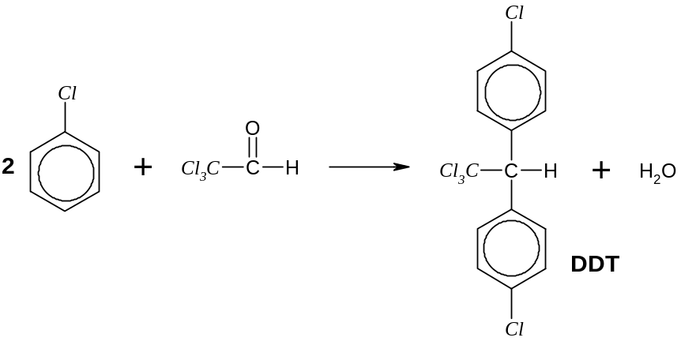
 | (a) | (i) | What type of reaction is this?
 |  | (ii) | Predict the sign of ΔS º for this reaction. Explain your answer.
 |  |  | [3]
 | (b) | In an experiment, DDT is heated with excess sodium hydroxide, acidified with excess nitric acid and then treated with excess aqueous silver nitrate.  A white precipitate C is obtained, which dissolves in excess aqueous ammonia to produce a colourless solution D.
 |  | (i) | Explain the purpose of each of the following steps:
 |  |  | 1 | boiling DDT with excess sodium hydroxide
 |  |  | 2 | acidifying with excess nitric acid before treating with aqueous silver nitrate
 |  | (ii) | Identify the white precipitate C.
 |  | (iii) | Write a balanced equation for the reaction between C and excess aqueous ammonia to form the colourless solution D.
 |  | (iv) | The colourless solution D can be used to identify one of the reactants in the synthesis of DDT.  Name this reactant and state the expected observations made.
 |  |  | reactant:
 |  |  | observations:
 |  |  | [6]
 |  |  | [Total: 9]

5 | (a) | Adrenalin is a hormone, which when secreted directly into the bloodstream, acts as a stimulant. It has the following structure:  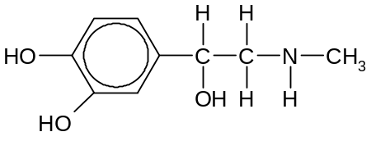  adrenalin
 |  | (i) | Draw structural formulae of adrenaline to illustrate the type of isomerism it exhibits.
 |  | (ii) | When adrenaline is heated at 400ºC over Al₂O₃, two isomers are formed.  Draw labelled, displayed formulae of these two isomers.
 |  | (iii) | Benzedrin is also a stimulant and has the following structure.  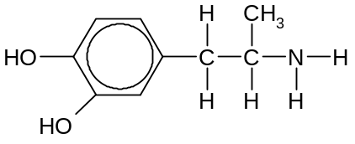  benzedrin  State and explain how the pK_{b} of benzedrin compares with that of adrenaline.
 |  |  | [6]
 | (b) | The following scheme shows how primary amines may be synthesized via Hoffmann’s degradation.  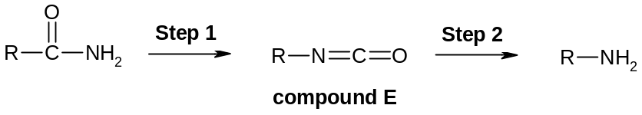
 |  | (i) | In Step 1, the amide is treated with LiAlH₄ in an inert solvent. State the role of LiAlH₄ in its reaction with the amide here.
 |  | (ii) | The intermediate product E is highly reactive. Other than the primary amine, a gas F that gives a white precipitate with aqueous calcium hydroxide is also released in Step 2.  Give the identity of gas F and suggest a suitable reagent to carry out this step.
 |  |  | gas F:
 |  |  | reagent:
 |  | (iii) | Complete the following table by providing the structure of the primary amine formed when each amide undergoes Hoffmann’s degradation.
   | Amide | Amine
  1 | 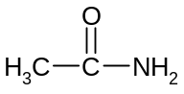
  2 | 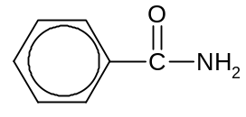
 |  | (iv) | Suggest a chemical test (stating reagents, conditions, and observations) that would enable the two amines in (iii) to be distinguished from each other.
 |  |  | [7]
 |  |  | [Total: 13]
~ END OF PAPER ~

